Hands On 13:**Solution**

Creating an image of .NET microservice using Docker and Storing the image in Elastic Container Registry.

1. Create a new .NET core API Project in VS 2019 enabling Docker.

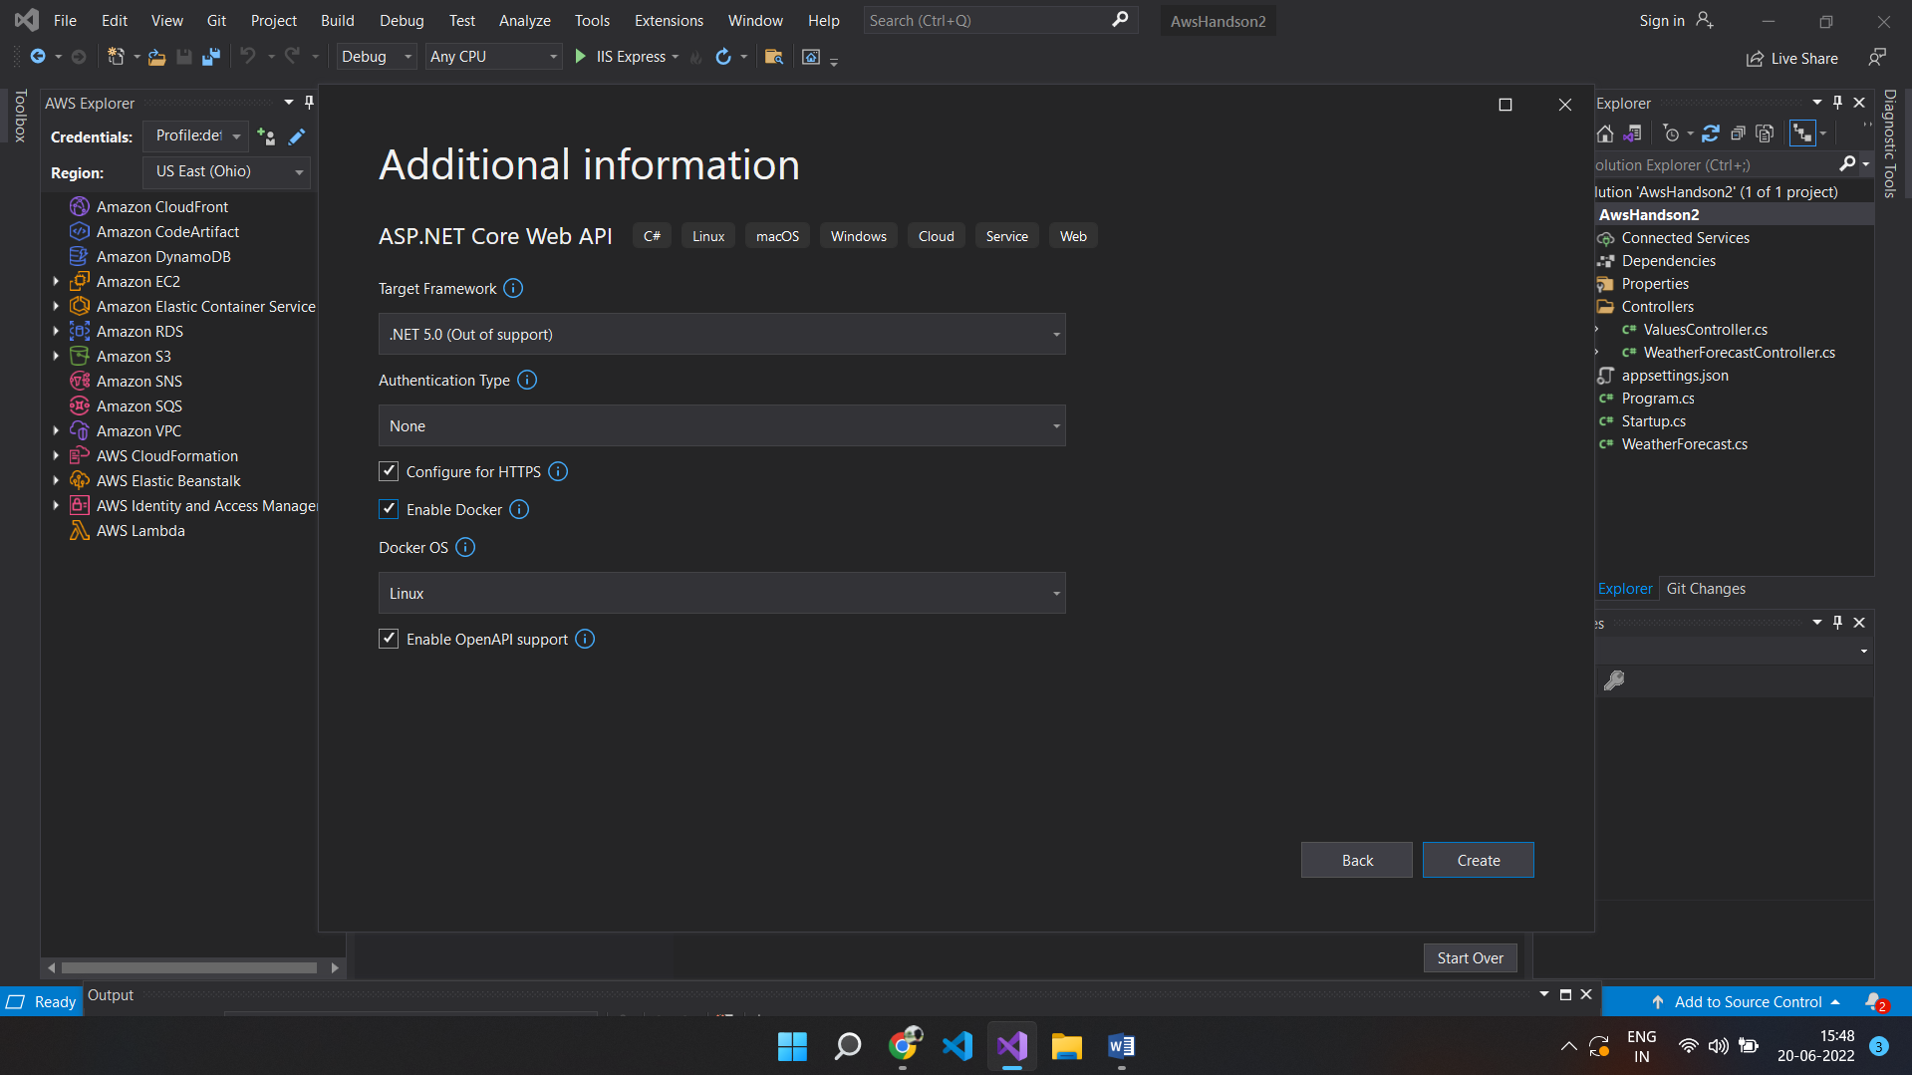

1. Install Docker Desktop in your system from the following link:

<https://docs.docker.com/desktop/windows/install/>

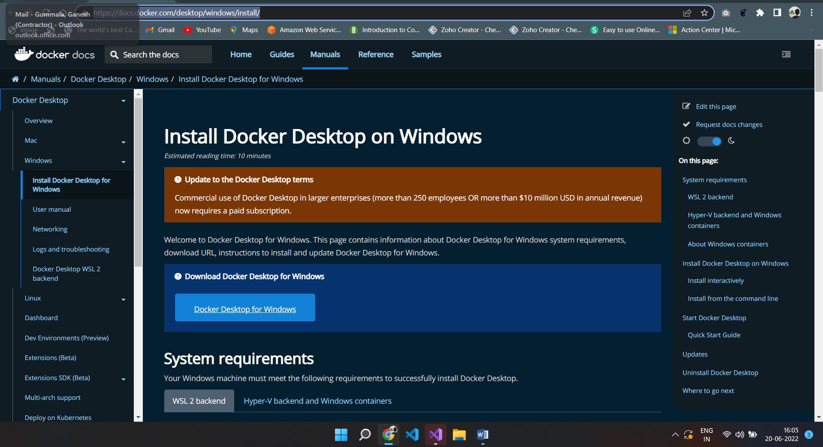

1. DockerFile gets Created as we have enabled Docker during the creation of the project



4. Run the Project on Docker so as to create an image of the project using Docker Desktop.

5. In Docker Desktop, the image can be found as shown below in the screenshot.

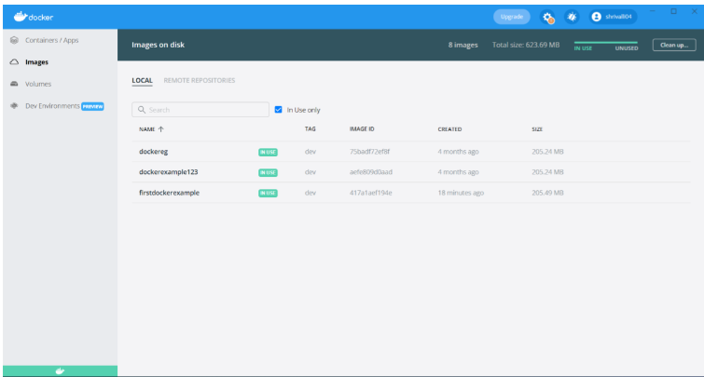

6. Right click on the project in the solution explorer and click on “publish container to AWS”

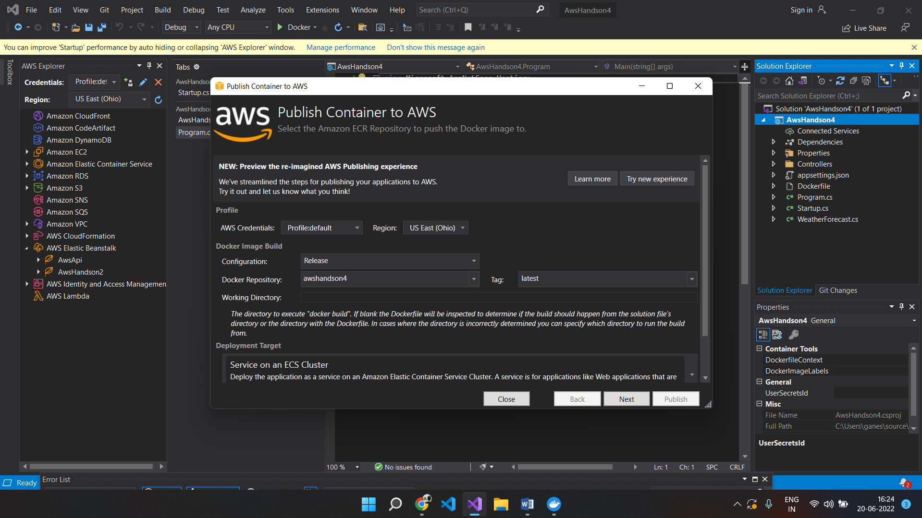

7. Once the steps are completed, the following screenshot appears.

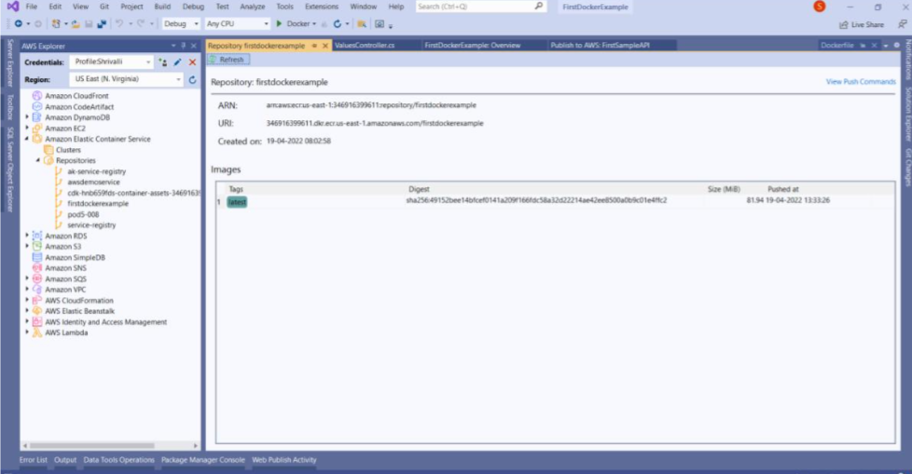

Note: In Aws Explorer, under Amazon Elastic Container Services à Repositories à we can see AwsHandson4 (image of our application)

8. Go to Portal and search for “Elastic Container Registry” and our image will be available as in the following screenshot

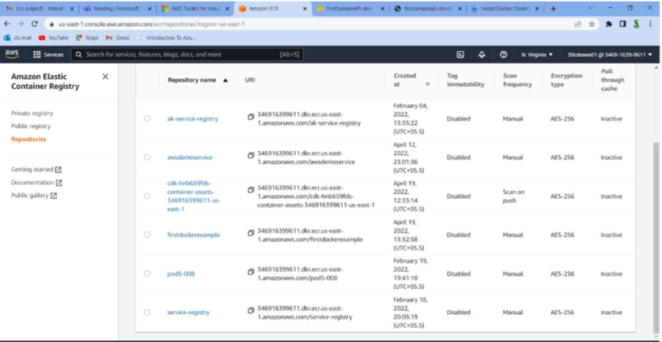

9. Click on the image so as to know the URL and other details of the image

